272 Android Studio and React Native CLI Install

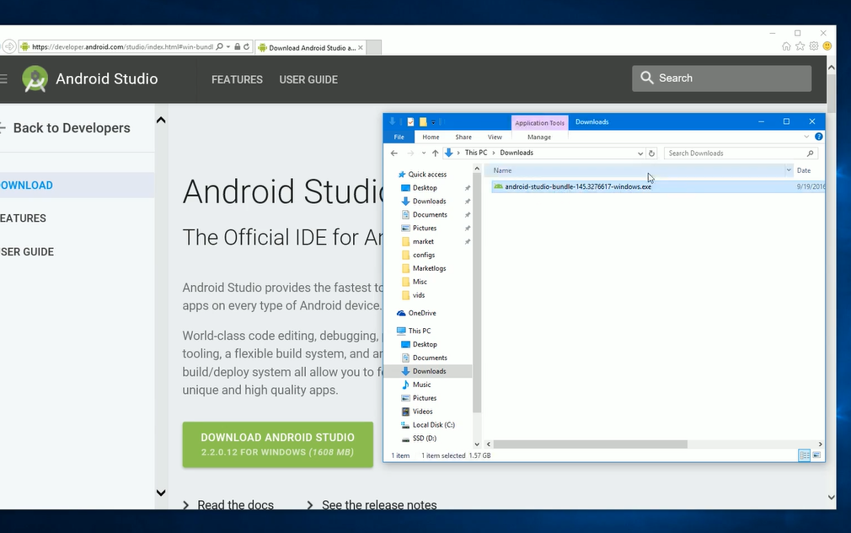

Start up install – takes a long time 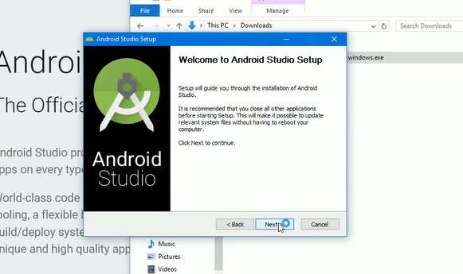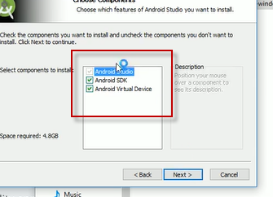

Take note of this address

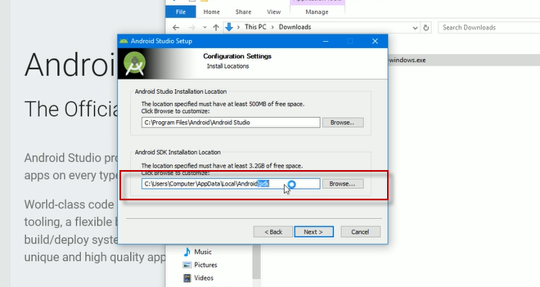

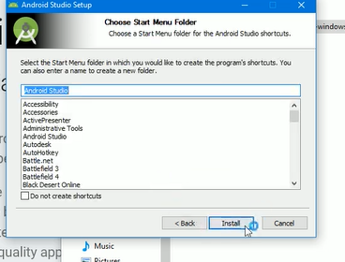

Will take a long time to install

Go to start menu and open the cmd prompt as an administrator

Check on install on node 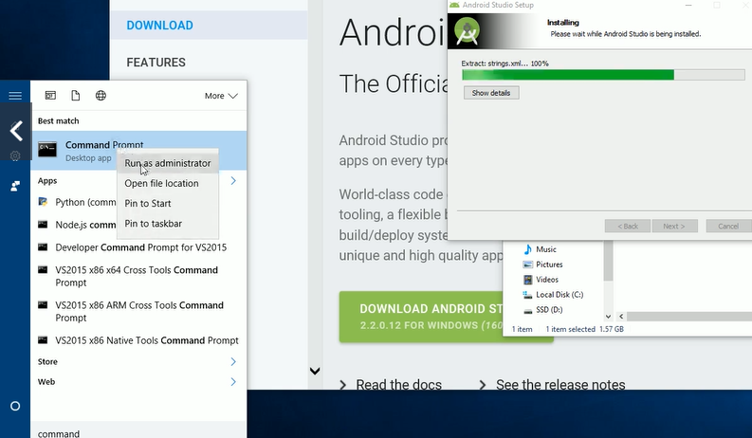

Install react native command line tools by running 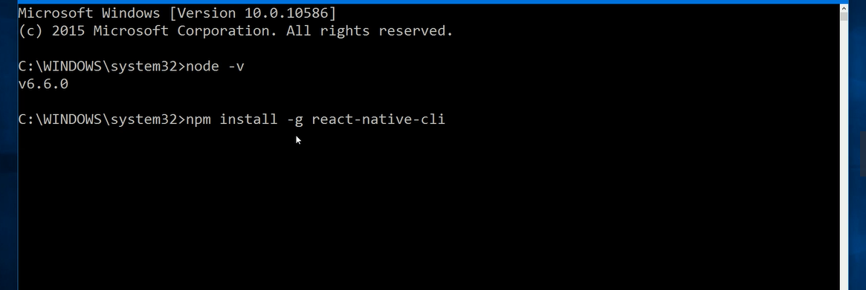

Use react native cli to create a project

CD to the correct location for the project

?? why not do this within VS code terminal

Here Steve named the folder reactnative and albums is the name of the project 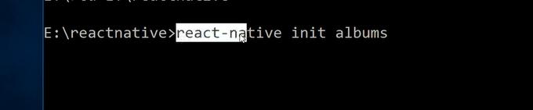

This takes a while to run